Overloading Constructors

1. Within a class, we can declare multiple constructors and all these constructors having same name but different type of arguments. Hence, all these constructors are considered as **“overloaded constructor**”. Hence, overloading concept is applicable for constructors.   
   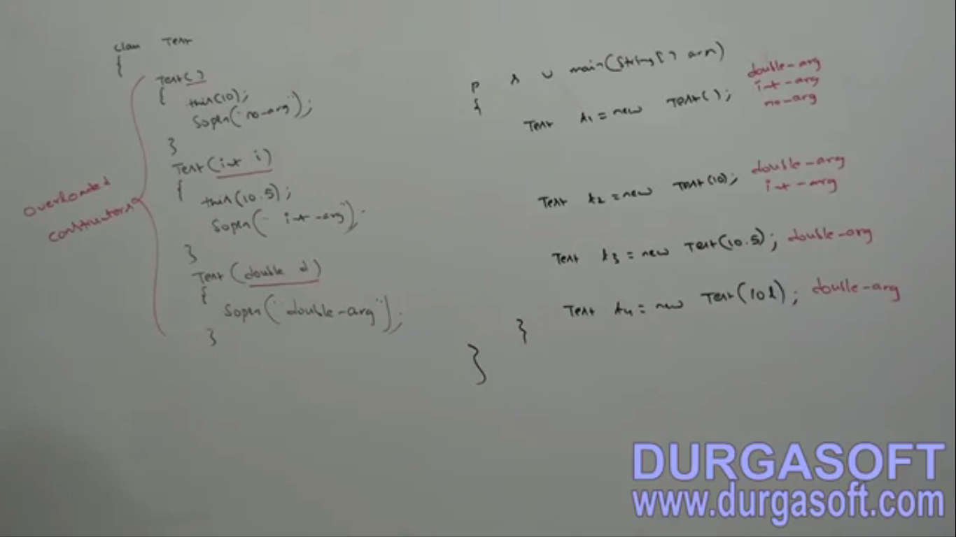
2. **Where overloading constructor is applicable?**
   1. Sometimes we have full initial info but sometimes partial info.

# Is inheritance applicable for constructors?

1. For constructors, Inheritance and overriding concepts are not applicable but overloading concept is applicable.

## Every class in java including abstract class can contain constructor but interface can’t have why?

Constructors are for instance variable initialization. But Interface doesn’t have instance variables.

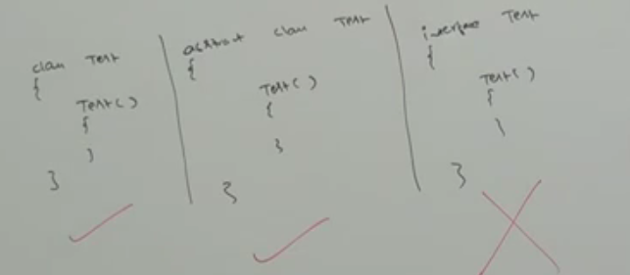

There are 3 important cases, each with a special info

* **Case 01**:
  + 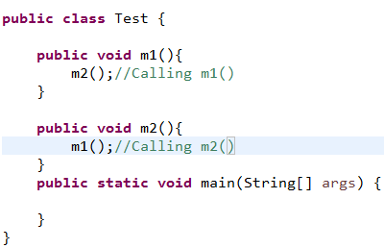

Recursive method call is **Runtime Error and it’s StackOverflowError**

Looks like **StackOverflowError But** we are not calling either of them.

* + 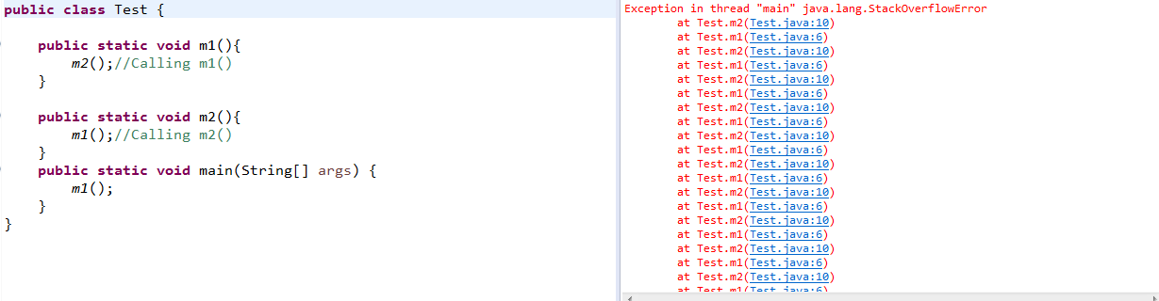
* **Case 02**:
  + 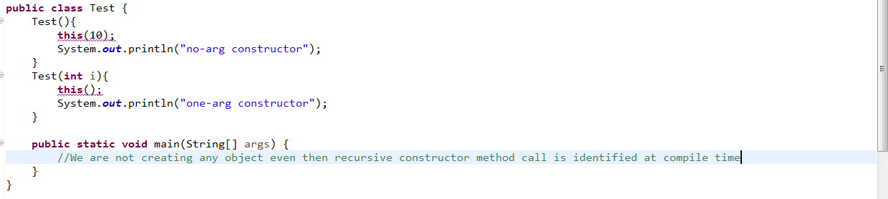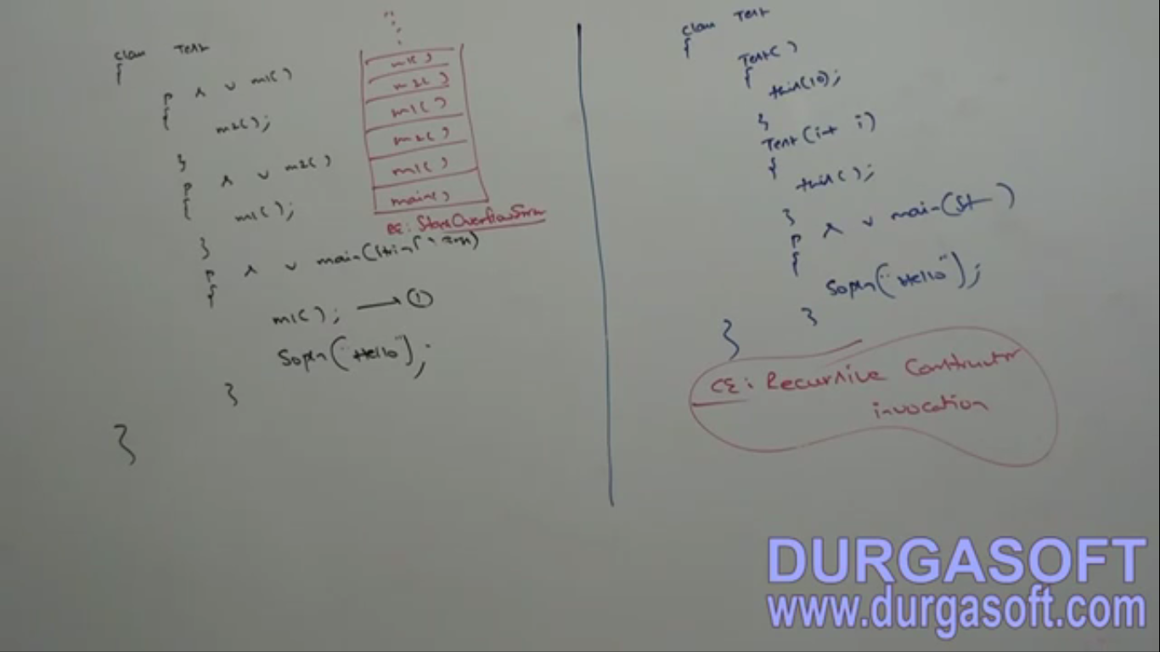

Even though we are not creating any object, recursive constructor call is identified by compiler.   
🡪 So recursive constructor call is **compile Time Error,** even though we are not creating any object **🡪** Recursive method call is runtime error 🡪 StackOverflowError  
  
**🡪** Recursive constructor call is checked by compiler as there is possibility for constructor to call.

* **Case 03**: Look below
  + 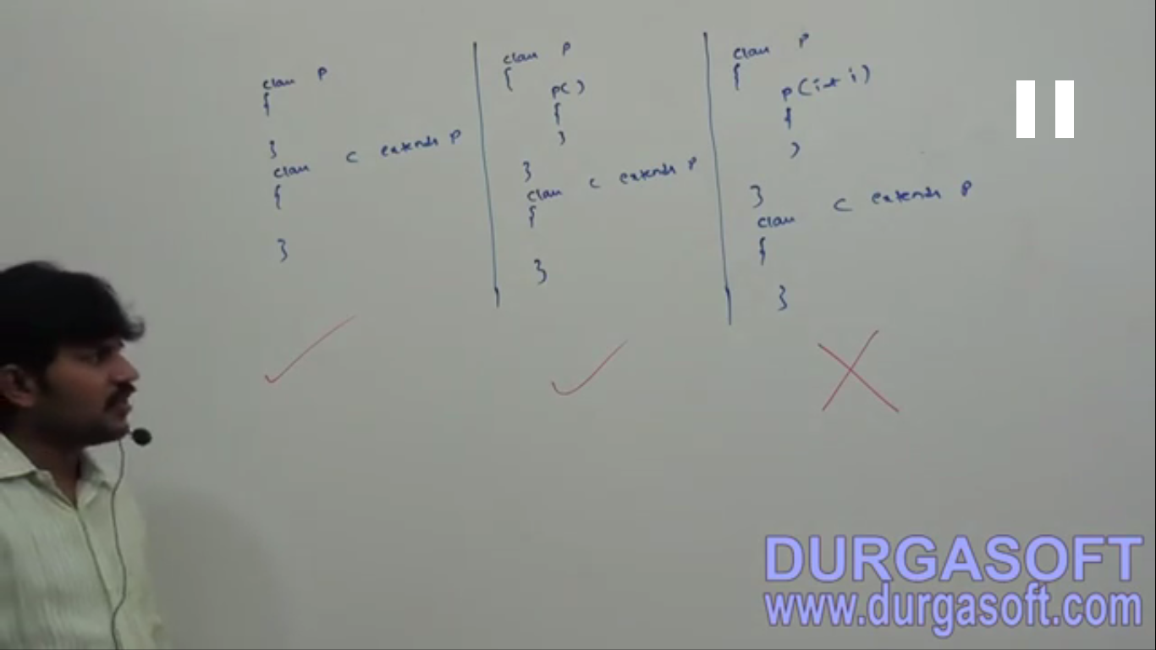Why 3rd one is invalid, see below  
    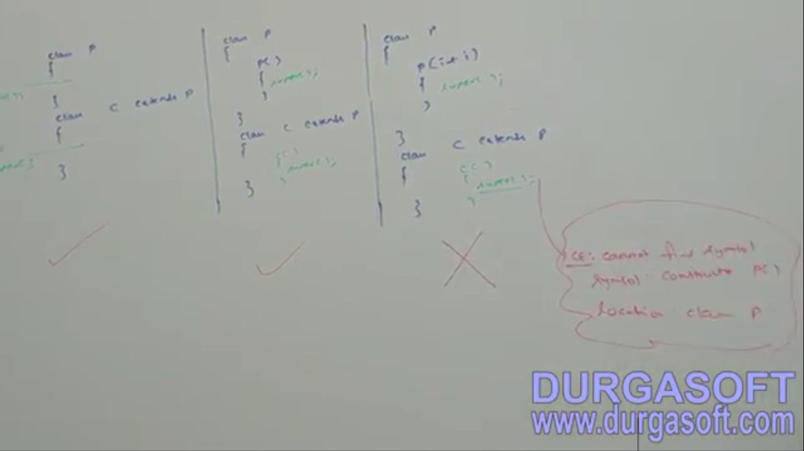

Exception in constructors

1. 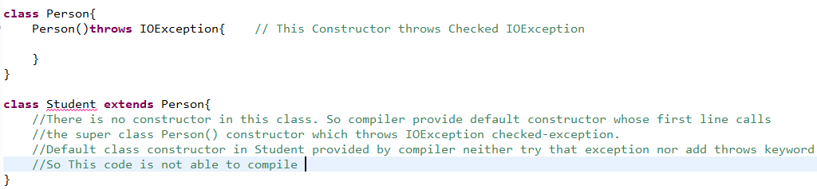  
   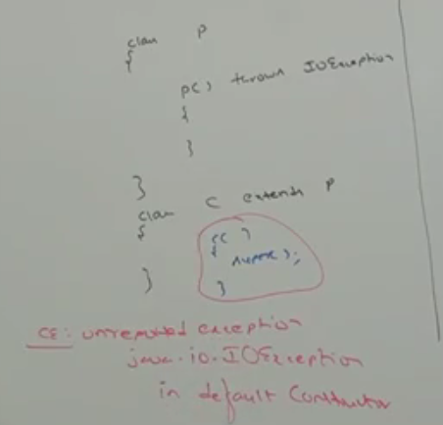  
   **Let’s try to resolve the exception handling**
   1. **1st try to handle Exception:**   
      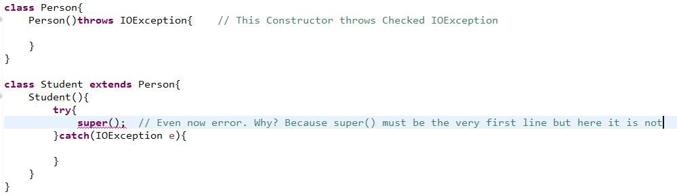
   2. **2nd try to handle Exception**:   
      All the following solutions are valid:  
      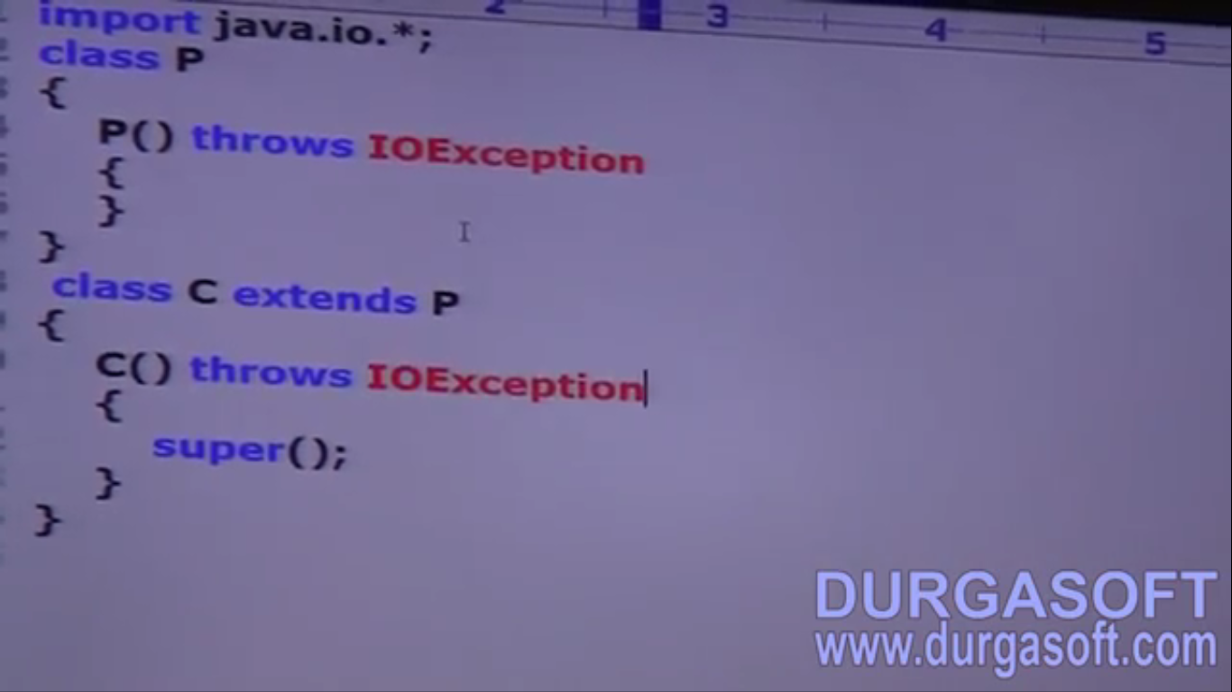

Solution 01

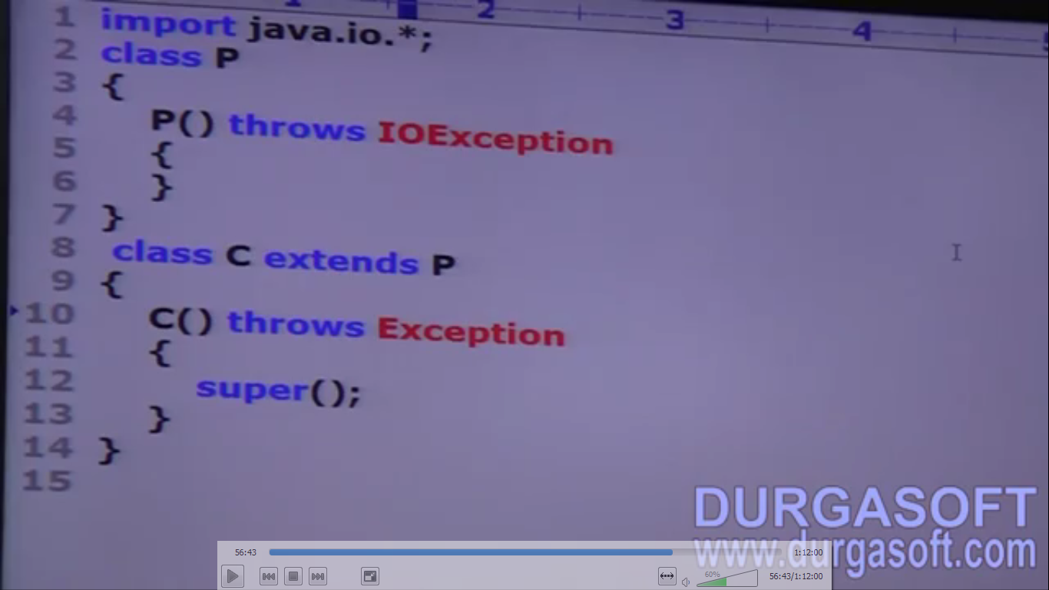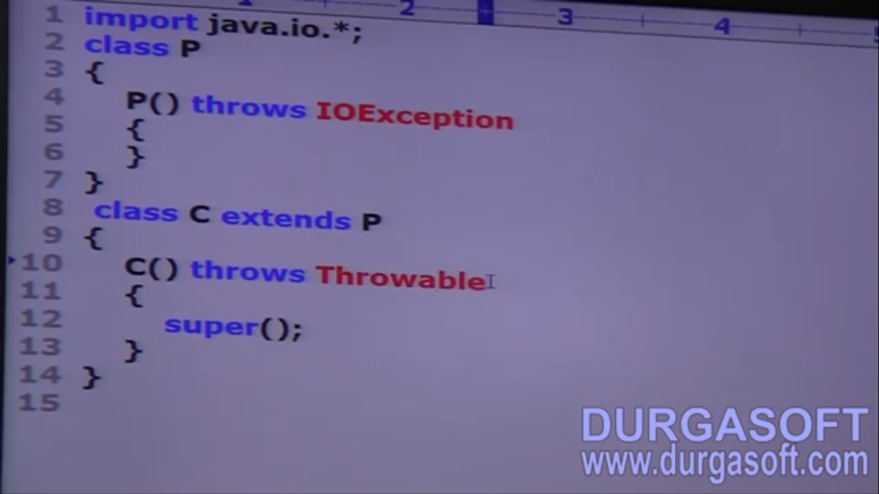

Parent constructor throws IOException but child throws Exception.   
**Note**: don’t apply overriding method exception rules here. Here we are not overriding constructors as constructors can’t be overridden.   
**NOTE**: Think of one constructor call from other constructor as method call from other method

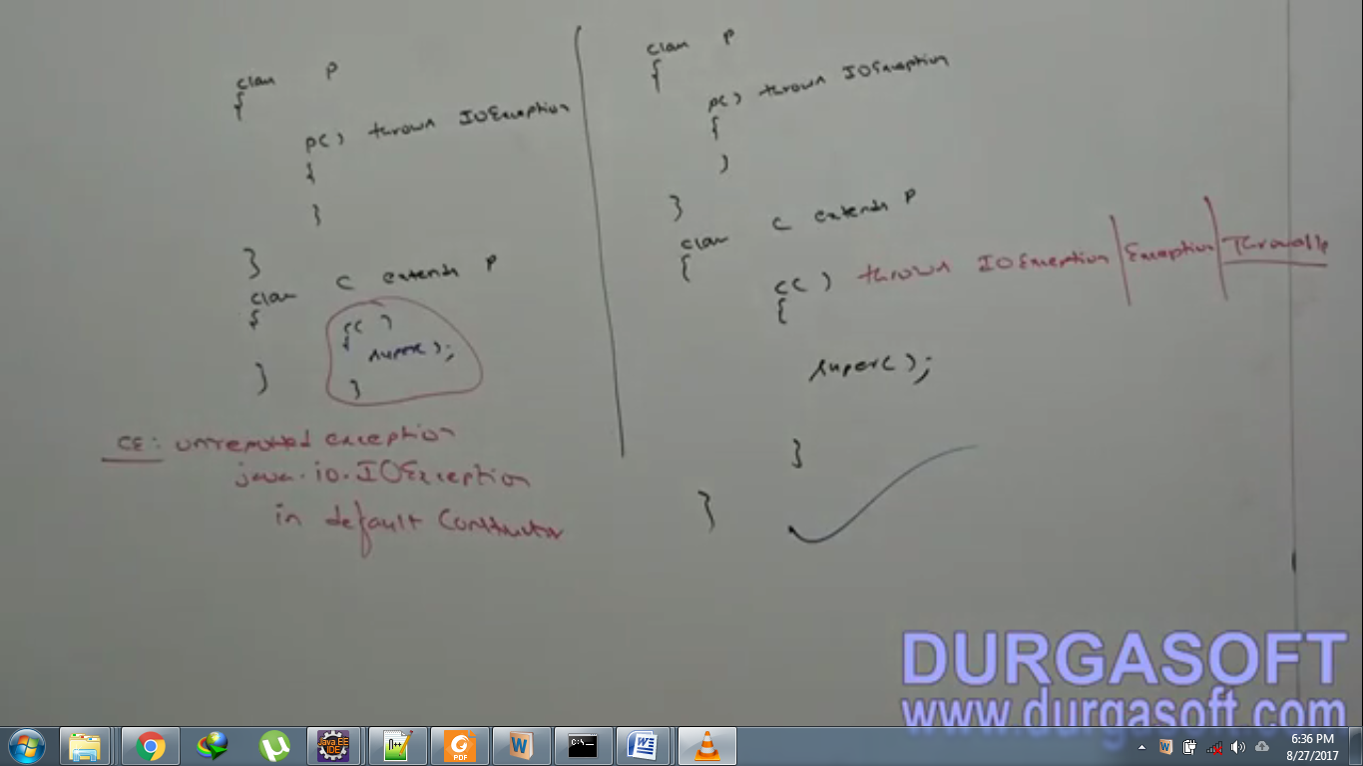

* 1. If parent class constructor throws any checked exception, compulsory, child class constructor must throw the same checked exception or its parent or along with other combinations otherwise code will not compile.

1. d

Summarizing Constructor

**Which of the followings are valid?**

1. **The main purpose of constructor is to create an object?**
   1. Invalid.
2. **The main purpose of constructor is to perform initialization of an object?**
   1. Valid.
3. **The name of the constructor needs not be same as that of class name?**
   1. Invalid.
4. **Return type concept is applicable for constructor but only void?**
   1. Invalid
5. **We can apply any modifier to constructor?**
   1. Invalid
6. **Default constructor is generated by JVM?**
   1. Invalid
7. **Compiler is responsible to generate default constructor?**
   1. Valid
8. **Compiler will always generate default constructor?**
   1. Invalid
9. **If we are not writing no-arg constructor then compiler will generate default constructor?**
   1. Invalid
10. **Every no-arg constructor is default constructor?**
    1. Invalid
11. **Default constructor is always no-arg constructor?**
    1. Valid
12. **The first line in every constructor must be either super() or this(). If we are not writing anything then compiler will generate this()?**
    1. Invalid
13. **For constructor both overloading and overriding concepts are applicable?**
    1. Invalid
14. **For Constructor, inheritance concept is applicable but not overriding?**
    1. Invalid
15. **Only concrete classes can contain constructor but abstract classes can’t?**
    1. Invalid
16. **Interface can contain constructor?**
    1. Invalid
17. **Recursive constructor invocation is run time exception?**
    1. Invalid
18. **If parent class constructor throws some checked-exception then compulsory child class constructor should throw the same checked-exception or its child?**
    1. Invalid